Year 6 (age 10-11)
A selection of books especially selected for children in Year 6 (10 - 11 year olds)
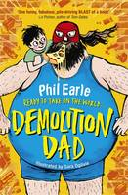 |  | A Storey Street Novel: Demolition Dad  Phil Earle

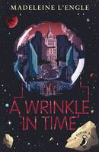 |  | A Wrinkle in Time  Madeleine L'Engle

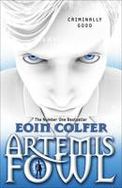 |  | Artemis Fowl  Eoin Colfer

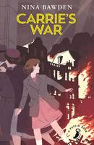 |  | Carrie's War  Nina Bawden, Julia Eccleshare

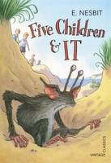 |  | Five Children and it  E. Nesbit

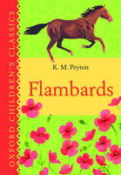 |  | Flambards: Oxford Children's Classics  K. M. Peyton

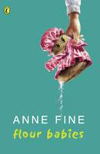 |  | Flour Babies  Anne Fine

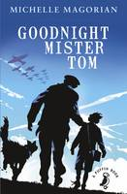 |  | Goodnight Mister Tom  Michelle Magorian

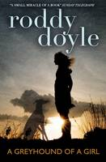 |  | Greyhound of a Girl  Roddy Doyle

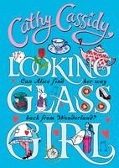 |  | Looking-Glass Girl  Cathy Cassidy

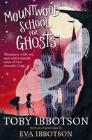 |  | Mountwood School for Ghosts  Toby Ibbotson

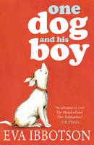 |  | One Dog and His Boy  Eva Ibbotson

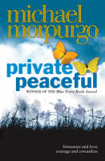 |  | Private Peaceful  Michael, M. B. E. Morpurgo

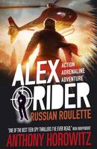 |  | Russian Roulette  Anthony Horowitz

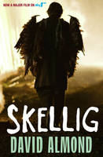 |  | Skellig  David Almond

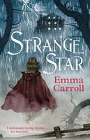 |  | Strange Star  Emma Carroll

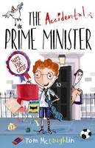 |  | The Accidental Prime Minister  Tom McLaughlin

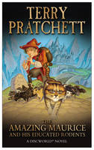 |  | The Amazing Maurice and  His Educated Rodents  (Discworld Novel 28)  Terry Pratchett

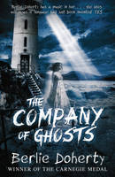 |  | The Company of Ghosts  Berlie Doherty

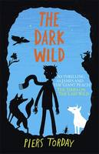 |  | The Dark Wild  Piers Torday

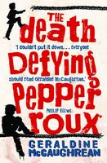 |  | The Death Defying Pepper Roux  Geraldine McCaughrean

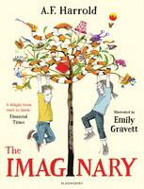 |  | The Imaginary  A. F. Harrold

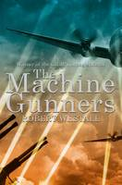 |  | The Machine Gunners  Robert Westall

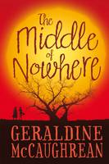 |  | The Middle of Nowhere  Geraldine McCaughrean

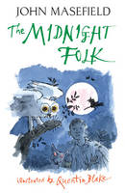 |  | The Midnight Folk  John Masefield

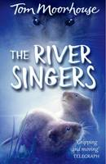 |  | The River Singers  Tom Moorhouse

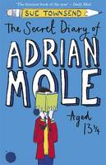 |  | The Secret Diary of Adrian Mole Aged 13 3/4  Sue Townsend

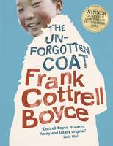 |  | The Unforgotten Coat  Frank Cottrell Boyce

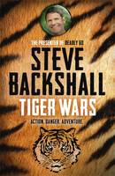 |  | Tiger Wars  Steve Backshall

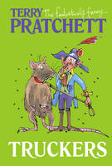 |  | Truckers The First Book of the Nomes  Terry Pratchett

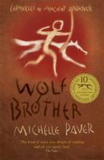 |  | Wolf Brother  Michelle Paver

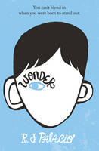 |  | Wonder  R. J. Palacio

