-Year 5
A selection of books especially selected for children in Year 5
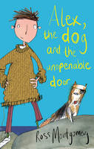 |  | Alex, the Dog and the Unopenable Door  Ross Montgomery

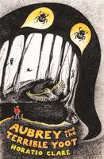 |  | Aubrey and the Terrible Yoot  Horatio Clare

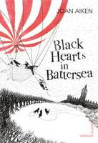 |  | Black Hearts in Battersea  Joan Aiken

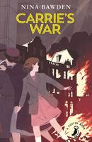 |  | Carrie's War  Nina Bawden, Julia Eccleshare

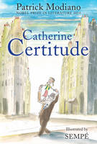 |  | Catherine Certitude  Patrick Modiano

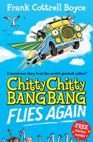 |  | Chitty Chitty Bang Bang 1: Flies Again  Frank Cottrell Boyce

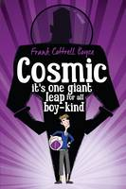 |  | Cosmic  Frank Cottrell Boyce

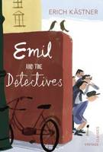 |  | Emil and the Detectives  Erich Kastner

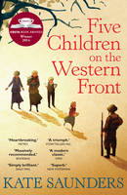 |  | Five Children on the Western Front  Kate Saunders

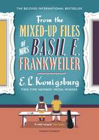 |  | From the Mixed-Up Files of Mrs. Basil E. Frankweiler  E.L. Konigsburg, Nathan Burton

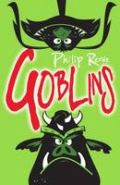 |  | Goblins  Philip Reeve

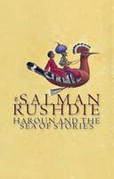 |  | Haroun and the Sea of Stories  Salman Rushdie

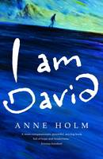 |  | I am David  Anne Holm

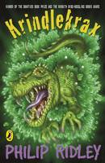 |  | Krindlekrax  Philip Ridley

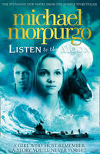 |  | Listen to the Moon  Michael Morpurgo

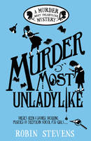 |  | Murder Most Unladylike  Robin Stevens

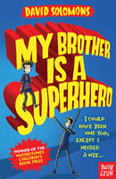 |  | My Brother is a Superhero  David Solomons, Laura Ellen Anderson,  Rob Biddulph

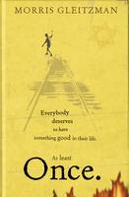 |  | Once  Morris Gleitzman

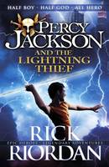 |  | Percy Jackson and the Lightning Thief  Rick Riordan

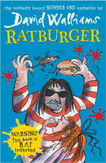 |  | Ratburger  David Walliams

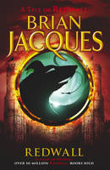 |  | Redwall  Brian Jacques

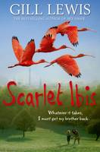 |  | Scarlet Ibis  Gill Lewis

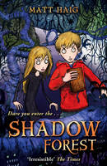 |  | Shadow Forest  Matt Haig

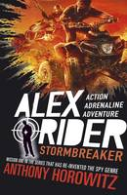 |  | Stormbreaker  Anthony Horowitz

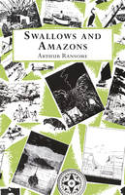 |  | Swallows and Amazons  Arthur Ransome

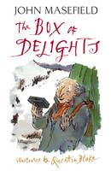 |  | The Box of Delights  John Masefield

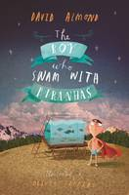 |  | The Boy Who Swam with Piranhas  David Almond

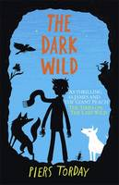 |  | The Dark Wild  Piers Torday

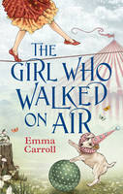 |  | The Girl Who Walked On Air  Emma Carroll

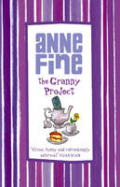 |  | The Granny Project  Anne Fine

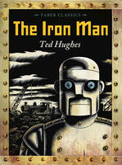 |  | The Iron Man  Ted Hughes

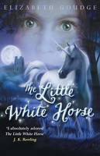 |  | The Little White Horse  Elizabeth Goudge

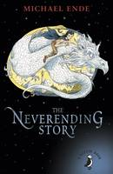 |  | The Neverending Story  Michael Ende

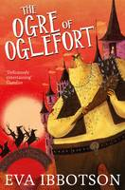 |  | The Ogre of Oglefort  Eva Ibbotson

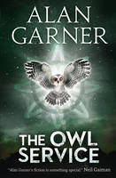 |  | The Owl Service  Alan Garner

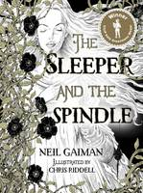 |  | The Sleeper and the Spindle  Neil Gaiman

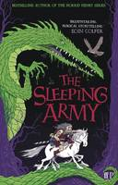 |  | The Sleeping Army  Francesca Simon

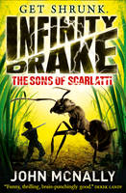 |  | The Sons of Scarlatti  John McNally

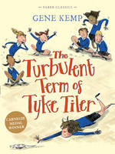 |  | The Turbulent Term of Tyke Tiler  Gene Kemp

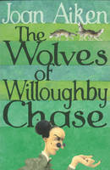 |  | The Wolves of Willoughby Chase  Joan Aiken

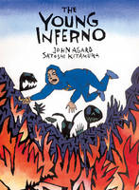 |  | The Young Inferno  John Agard

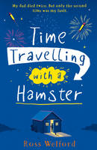 |  | Time Travelling with a Hamster  Ross Welford

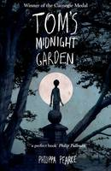 |  | Tom's Midnight Garden  Philippa Pearce

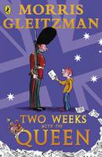 |  | Two Weeks with the Queen  Morris Gleitzman

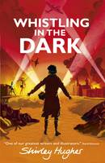 |  | Whistling in the Dark  Shirley Hughes

