-Year 4
A selection of books especially selected for children in Year 4 (8 - 9 year olds)
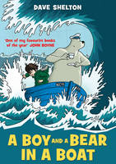 |  | A Boy and a Bear in a Boat  Dave Shelton

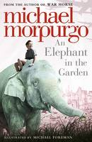 |  | An Elephant in the Garden  Michael, O. B. E. Morpurgo

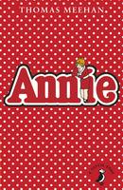 |  | Annie  Thomas Meehan

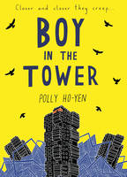 |  | Boy in the Tower  Polly Ho-Yen

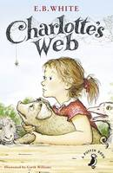 |  | Charlotte's Web  E. B. White

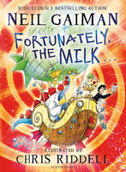 |  | Fortunately, the Milk ...  Neil Gaiman

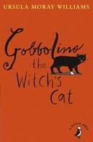 |  | Gobbolino the Witch's Cat  Ursula Moray Williams

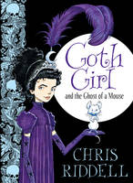 |  | Goth Girl and the Ghost of a Mouse  Chris Riddell

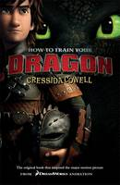 |  | How to Train Your Dragon  Cressida Cowell

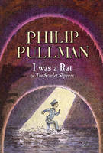 |  | I Was a Rat! Or, the Scarlet slippers  Philip Pullman

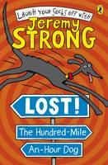 |  | Lost! The Hundred-Mile-An-Hour Dog  Jeremy Strong

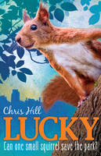 |  | Lucky  Chris Hill

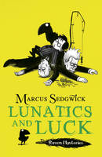 |  | Lunatics and Luck  Marcus Sedgwick

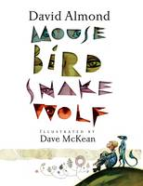 |  | Mouse Bird Snake Wolf  David Almond

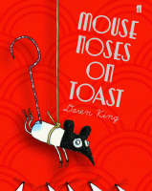 |  | Mouse Noses on Toast  Daren King

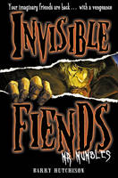 |  | Mr Mumbles  Barry Hutchison

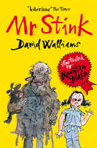 |  | Mr Stink  David Walliams

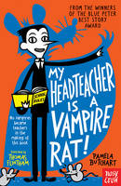 |  | My Head Teacher is a Vampire Rat  Pamela Butchart

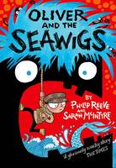 |  | Oliver and the Seawigs  Philip Reeve

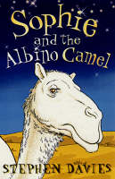 |  | Sophie and the Albino Camel  Stephen Davies

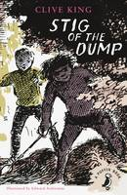 |  | Stig of the Dump  Clive King

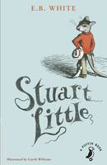 |  | Stuart Little  E. B. White

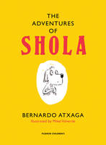 |  | The Adventures of Shola  Bernardo Atxaga, Mikel Valverde

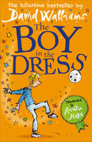 |  | The Boy in the Dress  David Walliams

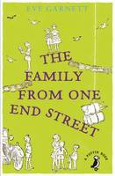 |  | The Family from One End Street  Eve Garnett

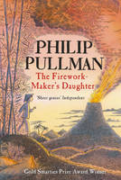 |  | The Firework-Maker's Daughter  Philip Pullman

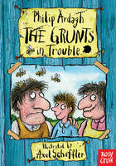 |  | The Grunts in Trouble  Philip Ardagh

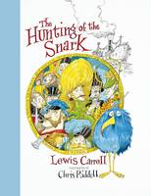 |  | The Hunting of the Snark  Chris Riddell, Lewis Carroll, Chris Riddell

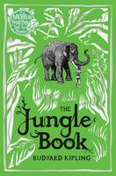 |  | The Jungle Book  Rudyard Kipling

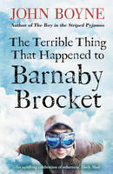 |  | The Terrible Thing That Happened to Barnaby Brocket  John Boyne

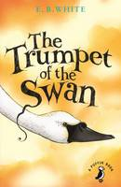 |  | The Trumpet of the Swan  E. B. White

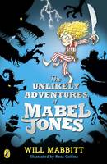 |  | The Unlikely Adventures of Mabel Jones  Will Mabbitt

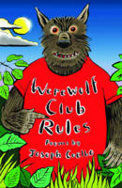 |  | Werewolf Club Rules! And Other Poems  Joseph Coelho

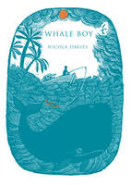 |  | Whale Boy  Nicola Davies

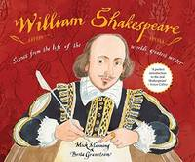 |  | William Shakespeare Scenes from the Life of the World's Greatest Writer  Mick Manning

