Year 3 (age 7-8)
A selection of books especially selected for children in Year 3 (7 - 8 year olds)
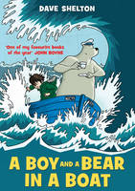 |  | A Boy and a Bear in a Boat  Dave Shelton

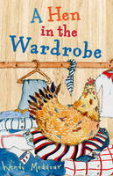 |  | A Hen in the Wardrobe  Wendy Meddour

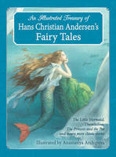 |  | An Illustrated Treasury of Hans Christian Andersen's Fairy Tales The Little Mermaid, Thumbelina, the Princess and the Pea and Many More Classic Stories  Hans Christian Andersen

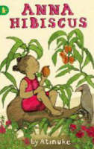 |  | Anna Hibiscus  Atinuke, Lauren Tobia

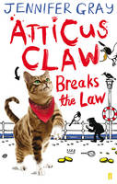 |  | Atticus Claw Breaks the Law  Jennifer, (Children's story writer) Gray

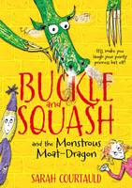 |  | Buckle and Squash and the Monstrous Moat-dragon  Sarah Courtauld

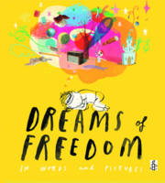 |  | Dreams of Freedom  Amnesty International

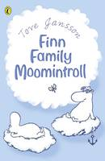 |  | Finn Family Moomintroll  Tove Jansson

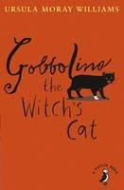 |  | Gobbolino the Witch's Cat  Ursula Moray Williams

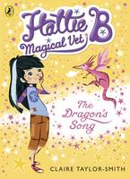 |  | Hattie B, Magical Vet: The Dragon's Song (Book 1)  Claire Taylor-Smith

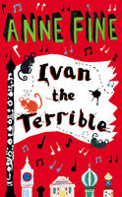 |  | Ivan the Terrible  Anne Fine

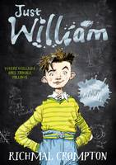 |  | Just William  Richmal Crompton

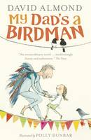 |  | My Dad's a Birdman  David Almond

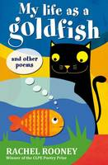 |  | My Life as a Goldfish And Other Poems  Rachel Rooney

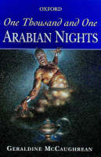 |  | One Thousand and One Arabian Nights  Geraldine McCaughrean

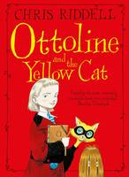 |  | Ottoline and the Yellow Cat  Chris Riddell

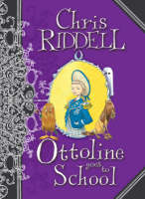 |  | Ottoline Goes to School  Chris Riddell

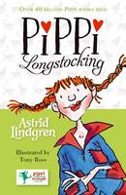 |  | Pippi Longstocking  Astrid Lindgren

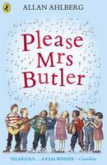 |  | Please Mrs. Butler Verses  Allan Ahlberg

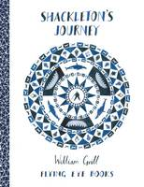 |  | Shackleton's Journey  William Grill

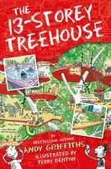 |  | The 13-Storey Treehouse  Andy Griffiths

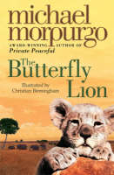 |  | The Butterfly Lion  Michael, O. B. E. Morpurgo

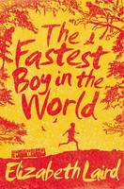 |  | The Fastest Boy in the World  Elizabeth Laird

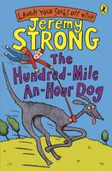 |  | The Hundred-mile-an-hour Dog  Jeremy Strong

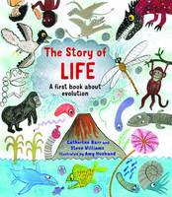 |  | The Story of Life A First Book About Evolution  Catherine Barr, Steve Williams

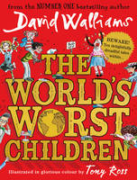 |  | The World's Worst Children  David Walliams

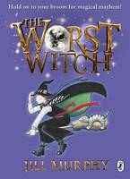 |  | The Worst Witch  Jill Murphy

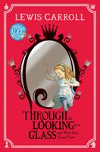 |  | Through the Looking-Glass  Lewis Carroll

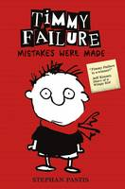 |  | Timmy Failure: Mistakes Were Made  Stephan Pastis

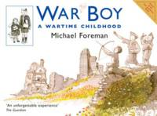 |  | War Boy A Wartime Childhood  Michael Foreman

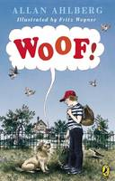 |  | Woof!  Allan Ahlberg

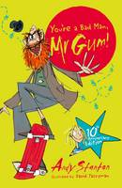 |  | You're a Bad Man, Mr Gum!  Andy Stanton

