Year 2 (age 6-7)
A selection of books especially selected for children in Year 2 (6 - 7 year olds)
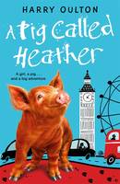 |  | A Pig Called Heather  Harry Oulton

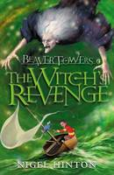 |  | Beaver Towers Witches Revenge The Witch's Revenge  Nigel Hinton

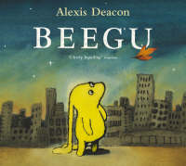 |  | Beegu  Alexis Deacon

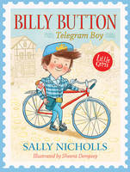 |  | Billy Button, Telegram Boy  Sally Nicholls

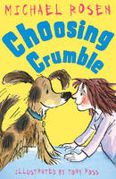 |  | Choosing Crumble  Michael Rosen

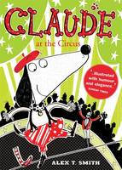 |  | Claude at the Circus  Alex T. Smith

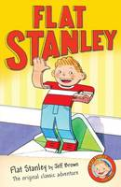 |  | Flat Stanley  Jeff Brown

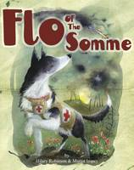 |  | Flo of the Somme  Hilary Robinson

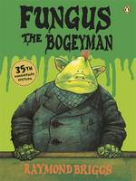 |  | Fungus the Bogeyman  Raymond Briggs

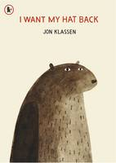 |  | I Want My Hat Back  Jon Klassen

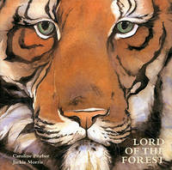 |  | Lord of the Forest  Caroline Pitcher

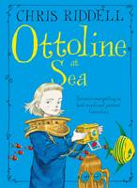 |  | Ottoline at Sea  Chris Riddell

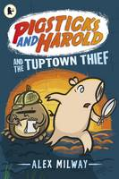 |  | Pigsticks and Harold and the Tuptown Thief  Alex Milway

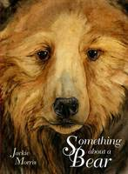 |  | Something About a Bear  Jackie Morris

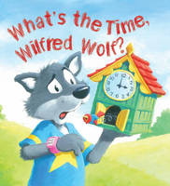 |  | Storytime: What's the Time, Wilfred Wolf?  Jessica Barrah

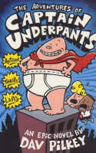 |  | The Adventures of Captain Underpants  Dav Pilkey

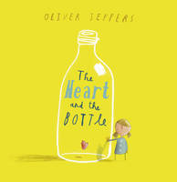 |  | The Heart and the Bottle  Oliver Jeffers

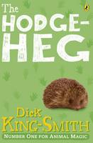 |  | The Hodgeheg  Dick King-Smith

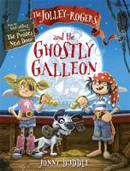 |  | The Jolley-Rogers and the Ghostly Galleon  Jonny Duddle

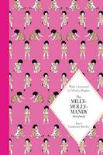 |  | The Milly-Molly-Mandy Storybook  Joyce Lankester Brisley

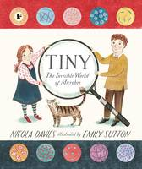 |  | Tiny The Invisible World of Microbes  Nicola Davies

