Year 1 (age 5-6)
A selection of books especially selected for children in Year 1
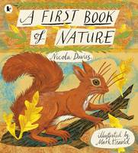 |  |  |  |  |  |  |  | A First Book of Nature  Nicola Davies
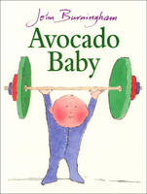 |  |  |  | Avocado Baby  John Burningham
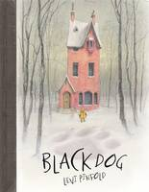 |  | Black Dog  Levi Pinfold
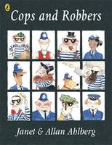 |  |  |  |  |  |  | Cops and Robbers  Allan Ahlberg

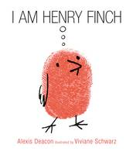 |  | I am Henry Finch  Alexis Deacon, Viviane Schwarz

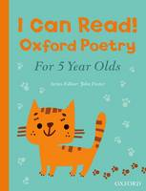 |  | I Can Read! Oxford Poetry for 5 Year Olds  John Foster

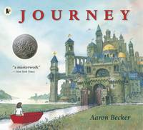 |  | Journey  Aaron Becker

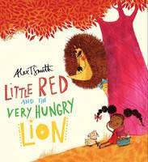 |  | Little Red and the Very Hungry Lion  Alex T. Smith

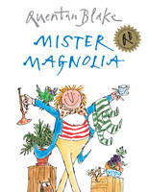 |  | Mister Magnolia  Quentin Blake

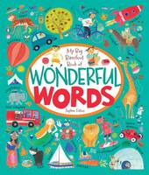

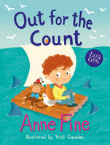 |  | Out for the Count  Anne Fine

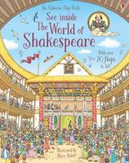 |  | See Inside the World of Shakespeare  Rob Lloyd Jones
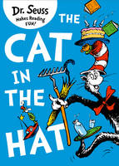 |  | The Cat in the Hat  Dr. Seuss
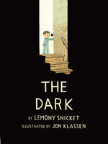 |  | The Dark  Lemony Snicket
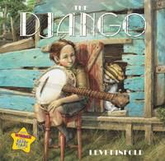 |  | The Django  Levi Pinfold
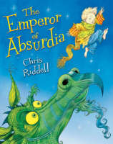
The Emperor of Absurdia
Chris Riddell
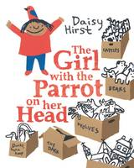 |  | The Girl with the Parrot on Her Head  Daisy Hirst
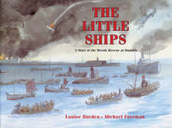 |  |  |  | The Little Ships A Story of the Heroic Rescue at Dunkirk  Louise Borden
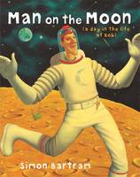 |  |  |  |  |  | The Man on the Moon  Simon Bartram

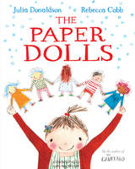 |  | The Paper Dolls  Julia Donaldson
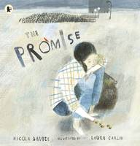 |  |  |  |  | The Promise  Nicola Davies

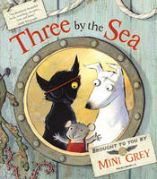 |  |  |  | Three by the Sea  Mini Grey

